**Finding Police Station: A Mobile App for Android Platform**

By

Shreya Khisa

ID:13701066

Kavi Zahan Sultana

ID:13701017

**Abstract**

This report presents “Finding Police Station”, an android application for smartphones with android operating system. It provides the facility of user location (latitude, longitude), police stations near user location along with their information details. User location allows user to find his current location with its latitude and longitude. Then the app searches for nearby police stations by Google Place API service within a certain range. If it finds the police stations it shows it on map and shows its details information like area, vicinity, latitude, longitude, phone number, Email in a different window. Here, in this report the design and implementation of the application is discussed first .Then the result of the complete program is shown in a screenshot of the implemented application. Finally, we conclude the discussion with the ideas of future development of the application in many aspects.

**Introduction**

Android operating system is one of the hottest topics to be discussed at present. It is the largest world-class mobile operating system (OS) for any smartphones and installation of it, is growing fast day by day. It is an operating system operated on touch screen for smartphones and tablet computers. It’s basically based on Linux Kernel and currently developed by Google.Smartphones with android operating system are highly equipped with GPS sensor, light sensor, proximity sensor, accelerometer, still and video camera, Bluetooth transceivers, Wi-Fi, 3G wireless radios capable streaming high bandwidth internet connection etc.

* **Motivation:**

As the popularity of android operating system is widely spreading day by day, android application development is the demand of time at present. This report focuses on android application development on Linux Kernel and Java environment. The application “FINDING POLICE STATION” finds the nearest police station placed near the user as it name indicates. First it finds the user location with GPS sensor and internet connection and then it searches for nearby police station instantly. Sometimes when people face any crimeslike hijacking, theft, gang-robbery, accidents and any kind of crimes, they may wish to find police and report it on police station. On such circumstances, this application is very useful to locate the nearby police station. This app will give the description of the area where the police station is situated, the phone number of the corresponding police station and a map view of the police station. As today smartphones are very handy among people, so an android application on this topic is preferable for all new or old android learners and developers. This motivation is worked behind the selection of this project. It is a location-based service (LBS) application. Location-based services (LBS) are a general class of computer-program-level services that use location data to control features. It is accessible with mobile devices through the mobile network which uses information on the geographical position of the mobile device. This app uses location-based services to locate user location through GPS sensor.

* **Current solution:**

There are apps which have developed to find nearest police station, but it lacks in some facts. Some of the existing apps such as “Bangladesh Police Station” developed by MCC LTD in Google play store, user has to type his/her division or district name to locate his/her location. But this app locates user location automatically through GPS and finds the nearby police station with its name of area, vicinity, latitude, longitude, phone number and URL.

**Related Work**

There are some existing apps which are developed to find the nearest police station. Some of the names of those apps from Google play store are given below:

1. Bangladesh Police station

developed by MCC LTD.

1. Police Station Finder

developed by Techila Solutions Pvt. Ltd.

1. Police Station Finder

developed by SoftSolutions

**Proposed Method**

At this era of modern technology, mobile has become a useful device for every people. It is easy to carry than a PC, so it is a great device for locating device location as well as user location. The importance of location-sensing has already recognized by GPS (Global Positioning System). Most of the smartphones at present has the location-sensing capability at present. In this project, GPS has used to locate the user location with android operating system.

* **Fetching User location:**

User location as well as device location has to find first so that a radius can be set to search for the nearby police stations.

**Implementation:**

To implement this problem programmatically on android platform, thelatest Android Location API is used whichis introduced by Google. It is used with Google play services library. The new location API is called “FusedLocationApi” which connects with GoogleApiClient and provides user the best location available.

* **Nearby police station search:**

Last but not the least task is to find nearby police stations in nearby user location inside of a definite radius.

**Implementation:**

Google Places API is used on this regard. Google Places Api allows user to find variety of places such as establishments, prominent point of interest, geographic locations and more.

* **Nearby Places search:**

This nearby search requests search for places within nearby specified area. This nearby search requests is used to find the nearby police station by sending a Http request on this link:<https://maps.googleapis.com/maps/api/place/nearbysearch/json?>With the user longitude, latitude, a definite radius, place type, sensor and my Google browser key. Search responses are returned in the JSON (JavaScript Object Notation)within the URL request’s path. When the Google places returns JSON results from a search, it places them within an array. A method was created to parse the JSON data with Java environment. The placeswere placed with marker along with its place name, vicinity, latitude, longitude on the Google map. And it is made as another activity and attached with previous one.

* **Place Details:**

A place details request is an HTTP URL of the following form:

<https://maps.googleapis.com/maps/api/place/details/json>?

Request was sent along with Google Browser Key, reference and sensor. Place details responses are returned in the JSON format within the request’s URL path. A method was created to parse the place details JSON data with Java. It is made as another activity.

* **Map View:**

A map is needed for showing user location and nearby police stations on map so that people can easily get to know where he is and where are the police stations near him.

**Implementation:**

This problem is solved by using Google Maps API V2 (version 2). It uses Google Play Services as its support library. For using Google Maps V2, a Google Maps API key is created and it is attached with Android Manifest file as it is required. Then it is made as another activity and connected with the previous one.

Finally activities are added together to make the program as a complete application.

The total schematic diagram of the application is given below:

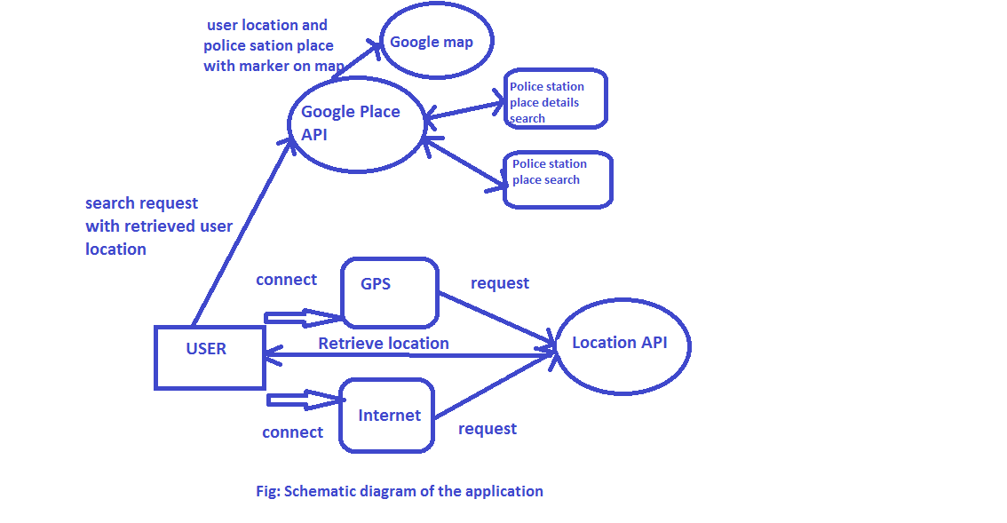

**Result:**

The above design and method is implemented in android platform with Java environment.

A screenshot of the complete application is given below:

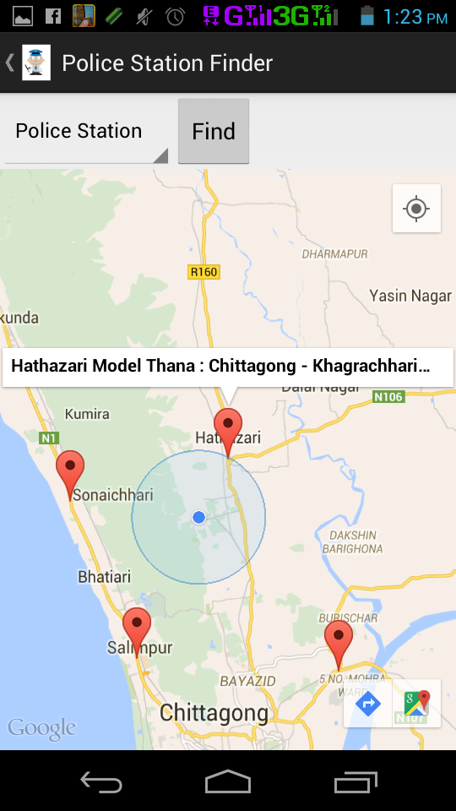

Here, when the button “Find” is pressed we find the nearby police stations around the user. Here in the screenshot we see that there is a circle inside which there is a blue point, indicates the user location. The red markers on the Google map are the police stations with their area and vicinity.

**Discussion**

In this report, the design, implementation and evaluation of project “Finding Police Station” is presented. This app provides the following facilities:

* The best location of the user provided by Google Play services.
* Perfect mapping of the Google map with the user location and police stations.
* Find nearby police stations with its area name, phone number, email and URL.

**Limitation:**

* It was planned to find the distance between user and the police station.

**Future Direction**

Finding Police Station app can be improved and extended using several ways. We have found some of those ways which can be used in future implementation of this app.

* A direct call to every police station can be made through some protocols.
* A traffic route between user location and the specific police station can be introduced.
* An optimization of battery power consumption can be made to use less battery power for the app.